 | Q1 |  |  | Q2 |  |  | Q3 | Q4
STID | A:1 | A:2 | B | A | B:1 | B:2 | Q3 | A:1 | A:2 | A:3 | B:1 | B:2 | C | Total
max point | 3 | 3 | 4 | 3 | 4 | 3 | 1 | 2 | 2 | 1 | 1 | 1 | 2 | 30
11238 | 0 | 0 | 1 | 0 | 1 | 0 | 0 | 0 | 0 | 0 | 0 | 0 | 0 | 2
66666 | 0 | 0 | 0 | 1.5 | 0 | 1 | 0.5 | 0 | 0 | 0 | 0 | 0 | 2 | 5
11471 | 2 | 0 | 2 | 1 | 1 | 1 | 0 | 0 | 2 | 0 | 0 | 0 | 0 | 9
33333 | 2 | 0 | 0 | 3 | 3 | 1 | 0 | 0 | 0 | 1 | 0 | 0 | 1 | 11
11111 | 3 | 0 | 2 | 0 | 0 | 0 | 0 | 2 | 1 | 1 | 0 | 0 | 2 | 11
11236 | 1 | 2 | 0 | 3 | 4 | 2 | 0 | 0 | 0 | 0 | 0 | 0 | 0 | 12
11482 | 1 | 1 | 1 | 1 | 1.5 | 2 | 0 | 2 | 2 | 0 | 0 | 0 | 2 | 13.5
11249 | 3 | 2 | 0 | 1 | 4 | 0 | 0 | 1 | 2 | 0 | 1 | 0.5 | 0 | 14.5
11426 | 3 | 2 | 3 | 1 | 3 | 0 | 1 | 0 | 0 | 0 | 0 | 0 | 2 | 15
44444 | 3 | 0 | 1 | 1 | 4 | 2.5 | 0.5 | 0 | 2 | 0 | 0 | 0 | 2 | 16
22222 | 1 | 0 | 0 | 2 | 4 | 3 | 0 | 2 | 2 | 0 | 1 | 0.5 | 1 | 16.5
11241 | 2 | 2 | 4 | 1.5 | 3 | 1 | 0 | 0 | 1 | 0 | 0 | 1 | 1 | 16.5
11255 | 2 | 2 | 2 | 1 | 4 | 1 | 0 | 0 | 2 | 1 | 1 | 1 | 2 | 19
11252 | 3 | 3 | 1 | 3 | 4 | 2 | 0.5 | 0 | 2 | 0 | 0 | 0 | 1 | 19.5
11242 | 0 | 1 | 4 | 1.5 | 3 | 2 | 1 | 2 | 2 | 0 | 1 | 0.5 | 2 | 20
11245 | 3 | 2 | 1 | 3 | 4 | 3 | 0.5 | 2 | 2 | 0 | 0 | 0 | 2 | 22.5

1.82 | 1 | 1.35 | 1.5 | 3 | 1.26 | 0.24 | 0.62 | 1.29 | 0.18 | 0.25 | 0.21 | 1.24
For  When  Column's  Mean  More than 1 | TOTAL >13 | ZEROs Count
For  When  Column's  Mean  More than 1 | 13.5 | 4
For  When  Column's  Mean  More than 1 | 14.5 | 3
For  When  Column's  Mean  More than 1 | 15 | 2
For  When  Column's  Mean  More than 1 | 16 | None
For  When  Column's  Mean  More than 1 | 16.5 | 1
For  When  Column's  Mean  More than 1 | 16.5 | None
For  When  Column's  Mean  More than 1 | 19 | None
For  When  Column's  Mean  More than 1 | 19.5 | None
For  When  Column's  Mean  More than 1 | 20 | None
For  When  Column's  Mean  More than 1 | 22.5 | none

 | Q1 |  |  | Q2 |  |  | Q3 | Q4
STID | A:1 | A:2 | B | A | B:1 | B:2 | Q3 | A:1 | A:2 | A:3 | B:1 | B:2 | C | Total
max point | 3 | 3 | 4 | 3 | 4 | 3 | 1 | 2 | 2 | 1 | 1 | 1 | 2 | 30
11238 | 0 | 0 | 1 | 0 | 1 | 0 | 0 | 0 | 0 | 0 | 0 | 0 | 0 | 2
66666 | 0 | 0 | 0 | 1.5 | 0 | 1 | 0.5 | 0 | 0 | 0 | 0 | 0 | 2 | 5
11471 | 2 | 0 | 2 | 1 | 1 | 1 | 0 | 0 | 2 | 0 | 0 | 0 | 0 | 9
33333 | 2 | 0 | 0 | 3 | 3 | 1 | 0 | 0 | 0 | 1 | 0 | 0 | 1 | 11
11111 | 3 | 0 | 2 | 0 | 0 | 0 | 0 | 2 | 1 | 1 | 0 | 0 | 2 | 11
11236 | 1 | 2 | 0 | 3 | 4 | 2 | 0 | 0 | 0 | 0 | 0 | 0 | 0 | 12
11482 | 1 | 1 | 1 | 1 | 1.5 | 2 | 0 | 2 | 2 | 0 | 0 | 0 | 2 | 13.5
11249 | 3 | 2 | 0 | 1 | 4 | 0 | 0 | 1 | 2 | 0 | 1 | 0.5 | 0 | 14.5
11426 | 3 | 2 | 3 | 1 | 3 | 0 | 1 | 0 | 0 | 0 | 0 | 0 | 2 | 15
44444 | 3 | 0 | 1 | 1 | 4 | 2.5 | 0.5 | 0 | 2 | 0 | 0 | 0 | 2 | 16
22222 | 1 | 0 | 0 | 2 | 4 | 3 | 0 | 2 | 2 | 0 | 1 | 0.5 | 1 | 16.5
11241 | 2 | 2 | 4 | 1.5 | 3 | 1 | 0 | 0 | 1 | 0 | 0 | 1 | 1 | 16.5
11255 | 2 | 2 | 2 | 1 | 4 | 1 | 0 | 0 | 2 | 1 | 1 | 1 | 2 | 19
11252 | 3 | 3 | 1 | 3 | 4 | 2 | 0.5 | 0 | 2 | 0 | 0 | 0 | 1 | 19.5
11242 | 0 | 1 | 4 | 1.5 | 3 | 2 | 1 | 2 | 2 | 0 | 1 | 0.5 | 2 | 20
11245 | 3 | 2 | 1 | 3 | 4 | 3 | 0.5 | 2 | 2 | 0 | 0 | 0 | 2 | 22.5

1.82 | 1 | 1.35 | 1.5 | 3 | 1.26 | 0.24 | 0.62 | 1.29 | 0.18 | 0.25 | 0.21 | 1.24
For  When  Column's  Mean  More than 1 | TOTAL <13 | ZEROs Count
For  When  Column's  Mean  More than 1 | 2 | 5
For  When  Column's  Mean  More than 1 | 5 | 3
For  When  Column's  Mean  More than 1 | 9 | 1
For  When  Column's  Mean  More than 1 | 11 | 2
For  When  Column's  Mean  More than 1 | 11 | 2
For  When  Column's  Mean  More than 1 | 12 | 3

I've decided to find the a correlation as much as possible among this dataset.
It was hard to caught any.
So I decided to rearrange them base on the total feature.
In order to move on stable ground; we find the mean of the total first
Next I've arrange the dataset increasingly start with the least value below the mean and the last value above the mean
Although the dataset seems in order; due to sparsity I had to take the mean for each feature individualy.
Finish

I applied pearson on this datasets. But due to sparsity. Pearson is not the right tools to catch correlations
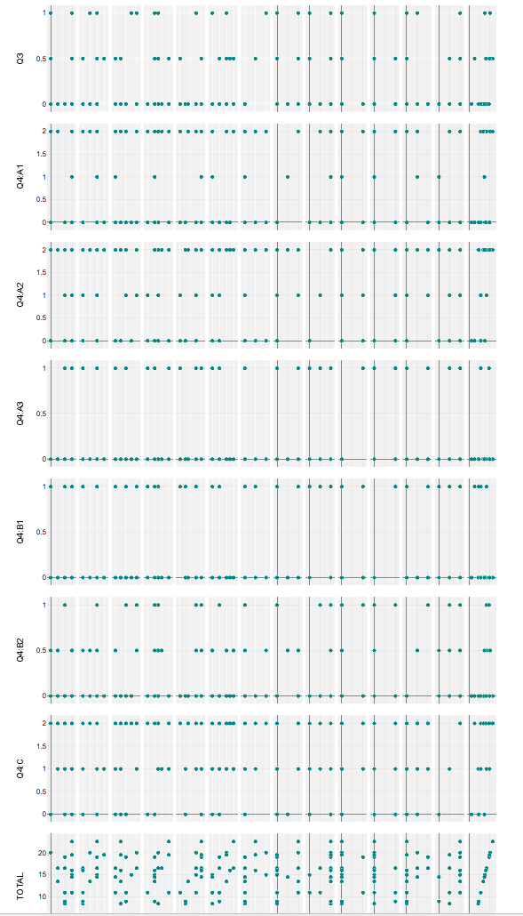
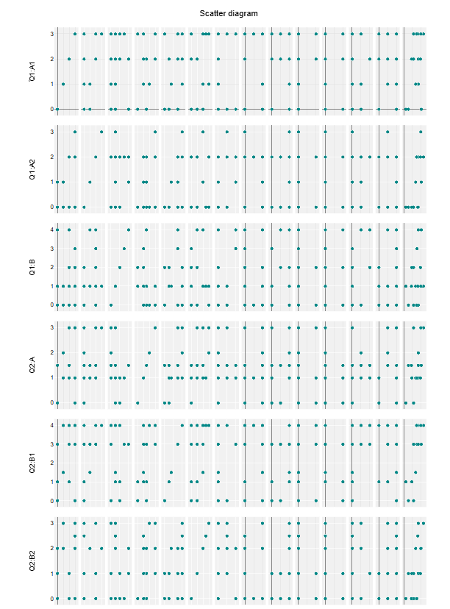

P C A
 | Q1:A1 | Q1:A2 | Q1:B | Q2:A | Q2:B1 | Q2:B2 | Q3 | Q4:A1 | Q4:A2 | Q4:A3 | Q4:B1 | Q4:B2 | Q4:C | TOTAL
Q1:A1 | 1.00 | 0.43 | -0.01 | 0.18 | 0.40 | -0.06 | -0.00 | -0.10 | 0.25 | 0.20 | -0.06 | -0.09 | 0.05 | 0.43
Q1:A2 | 0.43 | 1.00 | 0.31 | 0.33 | 0.60 | 0.10 | 0.30 | -0.02 | 0.24 | -0.13 | -0.25 | 0.38 | 0.10 | 0.68
Q1:B | -0.01 | 0.31 | 1.00 | -0.25 | 0.01 | -0.12 | 0.38 | 0.01 | 0.02 | -0.04 | 0.26 | 0.41 | 0.24 | 0.32
Q2:A | 0.18 | 0.33 | -0.25 | 1.00 | 0.51 | 0.56 | 0.20 | 0.01 | 0.15 | -0.06 | -0.28 | -0.06 | 0.07 | 0.49
Q2:B1 | 0.40 | 0.60 | 0.01 | 0.51 | 1.00 | 0.51 | 0.22 | 0.05 | 0.41 | -0.06 | -0.60 | 0.44 | 0.05 | 0.80
Q2:B2 | -0.06 | 0.10 | -0.12 | 0.56 | 0.51 | 1.00 | 0.23 | 0.43 | 0.50 | -0.25 | -0.26 | 0.04 | 0.34 | 0.61
Q3 | -0.00 | 0.30 | 0.38 | 0.20 | 0.22 | 0.23 | 1.00 | 0.05 | -0.10 | -0.34 | -0.20 | -0.19 | 0.52 | 0.38
Q4:A1 | -0.10 | -0.02 | 0.01 | 0.01 | 0.05 | 0.43 | 0.05 | 1.00 | 0.39 | -0.01 | -0.12 | 0.02 | 0.32 | 0.38
Q4:A2 | 0.25 | 0.24 | 0.02 | 0.15 | 0.41 | 0.50 | -0.10 | 0.39 | 1.00 | -0.21 | -0.25 | 0.25 | 0.01 | 0.58
Q4:A3 | 0.20 | -0.13 | -0.04 | -0.06 | -0.06 | -0.25 | -0.34 | -0.01 | -0.21 | 1.00 | 0.09 | 0.16 | 0.22 | -0.00
Q4:B1 | -0.06 | -0.25 | 0.26 | -0.28 | -0.60 | -0.26 | -0.20 | -0.12 | -0.25 | 0.09 | 1.00 | 0.05 | -0.05 | -0.35
Q4:B2 | -0.09 | 0.38 | 0.41 | -0.06 | 0.44 | 0.04 | -0.19 | 0.02 | 0.25 | 0.16 | 0.05 | 1.00 | -0.02 | 0.42
Q4:C | 0.05 | 0.10 | 0.24 | 0.07 | 0.05 | 0.34 | 0.52 | 0.32 | 0.01 | 0.22 | -0.05 | -0.02 | 1.00 | 0.42
TOTAL | 0.43 | 0.68 | 0.32 | 0.49 | 0.80 | 0.61 | 0.38 | 0.38 | 0.58 | -0.00 | -0.35 | 0.42 | 0.42 | 1.00

Component | Total | % of variance | Accumulated %
1 | 4.26 | 30.44 | 30.44
2 | 1.92 | 13.72 | 44.16
3 | 1.80 | 12.83 | 56.99
4 | 1.51 | 10.80 | 67.79
5 | 1.32 | 9.45 | 77.23
6 | 0.96 | 6.88 | 84.12
7 | 0.83 | 5.94 | 90.06
8 | 0.48 | 3.46 | 93.52
9 | 0.33 | 2.39 | 95.91
10 | 0.29 | 2.10 | 98.00
11 | 0.16 | 1.12 | 99.12
12 | 0.12 | 0.87 | 99.99
13 | 0.00 | 0.01 | 100.00
14 | 0.00 | 0.00 | 100.00
Interpretation
Each eigenvalue shows how much variance a component explains; values above 1 (Kaiser rule) often indicate meaningful components. The percent columns show the proportion and cumulative share of variance explained: look for a point where additional components add only small gains to decide on a sensible number of components. A clear elbow or leveling off in cumulative variance suggests the cutoff.
- Component 1 explains 30.4% of the variance, indicating a more balanced structure.
- The first 5 components account for 77.2% of total variance (based on the current factor count).
- 5 components exceed an eigenvalue of 1 (Kaiser criterion).
- Cumulative variance reaches 77.2% at component 5.
- Cumulative variance reaches 84.1% at component 6.

